**Uses of Alert dialog HTML**

**Use following parameters in set methods of AlertDialogHtml**

1. **Normal Without EditText :**

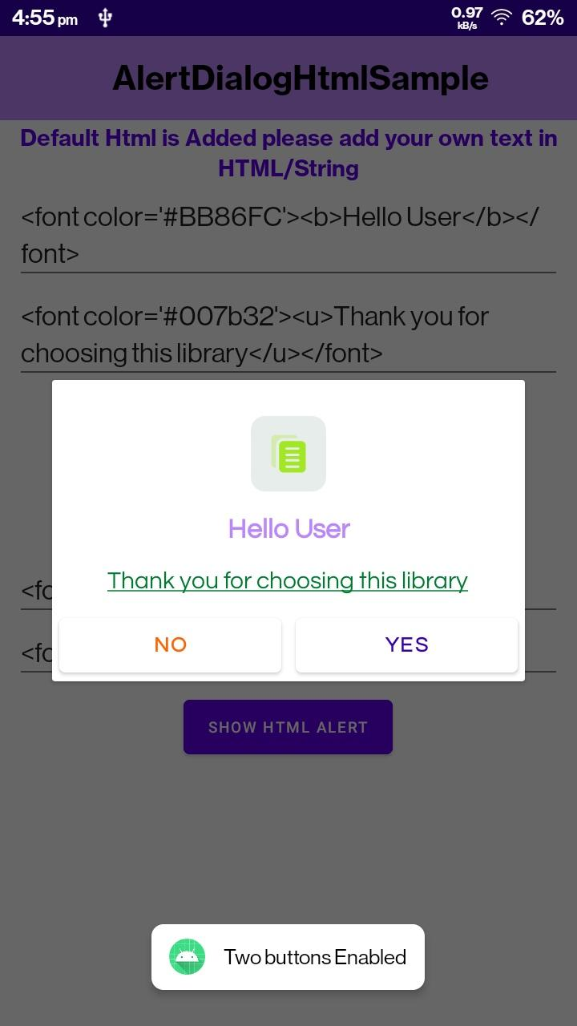

**new AlertDialogHtml.Builder(context)**

**.setTitle(title)**

**.setMessage(msg)**

**.setPositiveBtnText(stringbuttonfirst)**

**.setNegativeBtnText(stringbuttonsecond)**

**.setCancelableOnTouchOutside(true)**

**.setCancelable(true)**

**.setFont(Font.*QUESTRAILREGULAR*)**

**.setImage(R.drawable.*ic_copy*)**

**.setBothButtons(isBothBUtton)**

**.setTitleTextColor(R.color.*purple_700*)**

**.setAnimation(Animation.*DOWN*)**

**.setHtmlColors(isHtmlColor)**

**.setButtonTextColor(R.color.*purple_200*)**

**.setEditText(false, false, title, InputType.*PASSWORD*)**

**.OnPositiveClicked(new AlertDialogHtmlListner() {**

**@Override**

**public void OnClick(String input) {**

**Toast.*makeText*(context, "Positive"+"Text Value : "+input, Toast.*LENGTH_SHORT*).show();**

**}**

**})**

**.OnNegativeClicked(new AlertDialogHtmlListner() {**

**@Override**

**public void OnClick(String input) {**

**Toast.*makeText*(context, "Negative"+"Text Value : "+input, Toast.*LENGTH_SHORT*).show();**

**}**

**})**

**.build();**

1. **Dialog With EditText :**

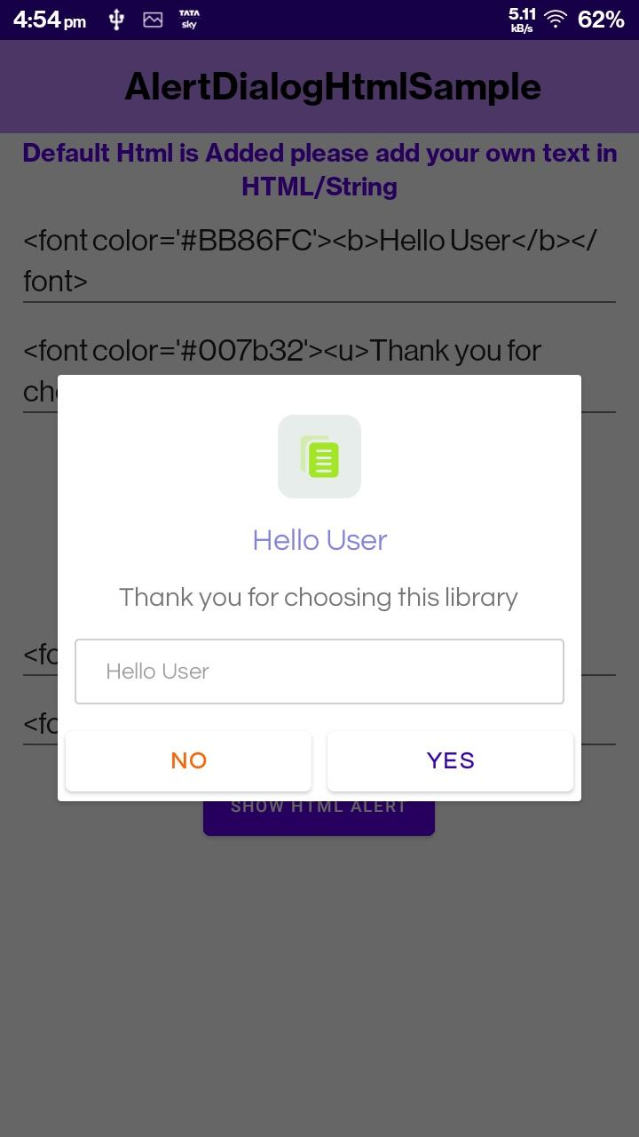

**new AlertDialogHtml.Builder(context)**

**.setTitle(title)**

**.setMessage(msg)**

**.setPositiveBtnText(stringbuttonfirst)**

**.setNegativeBtnText(stringbuttonsecond)**

**.setCancelableOnTouchOutside(true)**

**.setCancelable(true)**

**.setFont(Font.*QUESTRAILREGULAR*)**

**.setImage(R.drawable.*ic_copy*)**

**.setBothButtons(isBothBUtton)**

**.setTitleTextColor(R.color.*purple_700*)**

**.setCustomFont(R.font.*fudgie*)**

**.setAnimation(Animation.*DOWN*)**

**.setHtmlColors(isHtmlColor)**

**.setButtonTextColor(R.color.*purple_200*)**

**.setEditText(true, false, title, InputType.*PASSWORD*)**

**.OnPositiveClicked(new AlertDialogHtmlListner() {**

**@Override**

**public void OnClick(String input) {**

**Toast.*makeText*(context, "Positive"+"Text Value : "+input, Toast.*LENGTH_SHORT*).show();**

**}**

**})**

**.OnNegativeClicked(new AlertDialogHtmlListner() {**

**@Override**

**public void OnClick(String input) {**

**Toast.*makeText*(context, "Negative"+"Text Value : "+input, Toast.*LENGTH_SHORT*).show();**

**}**

**})**

**.build();**

1. **Dialog without HTML styling and with native styling:**



**new AlertDialogHtml.Builder(context)**

**.setTitle(title)**

**.setMessage(msg)**

**.setPositiveBtnText(stringbuttonfirst)**

**.setNegativeBtnText(stringbuttonsecond)**

**.setCancelableOnTouchOutside(true)**

**.setCancelable(true)**

**.setFont(Font.*QUESTRAILREGULAR*)**

**.setImage(R.drawable.*ic_copy*)**

**.setBothButtons(true)**

**.setTitleTextColor(R.color.*purple_700*)**

**.setAnimation(Animation.*DOWN*)**

**.setHtmlColors(false)**

**.setButtonTextColor(R.color.*purple_200*)**

**.setEditText(true, false, title, InputType.*PASSWORD*)**

**.OnPositiveClicked(new AlertDialogHtmlListner() {**

**@Override**

**public void OnClick(String input) {**

**Toast.*makeText*(context, "Positive"+"Text Value : "+input, Toast.*LENGTH_SHORT*).show();**

**}**

**})**

**.OnNegativeClicked(new AlertDialogHtmlListner() {**

**@Override**

**public void OnClick(String input) {**

**Toast.*makeText*(context, "Negative"+"Text Value : "+input, Toast.*LENGTH_SHORT*).show();**

**}**

**})**

**.build();**

1. **Dialog with Html tags in string including title,message,buttons text:**

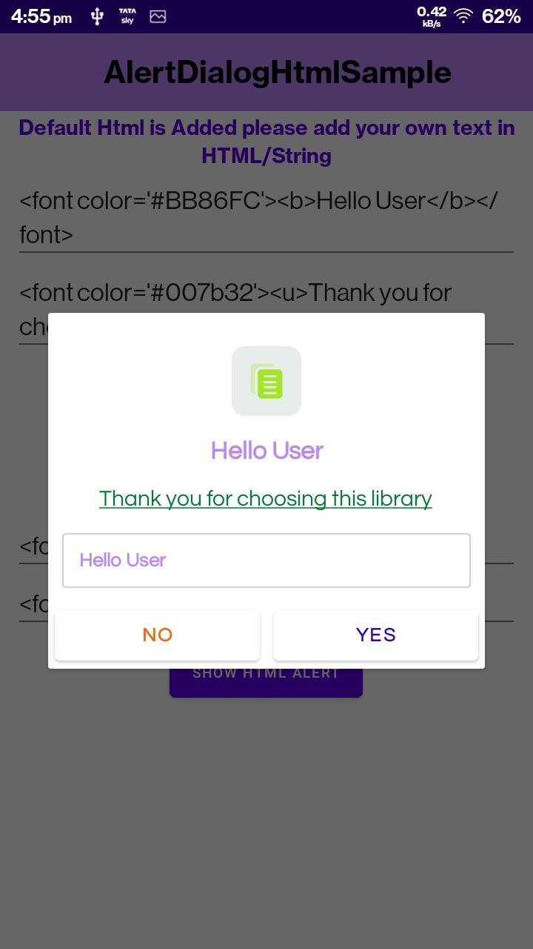

**new AlertDialogHtml.Builder(context)**

**.setTitle(title)**

**.setMessage(msg)**

**.setPositiveBtnText(stringbuttonfirst)**

**.setNegativeBtnText(stringbuttonsecond)**

**.setCancelableOnTouchOutside(true)**

**.setCancelable(true)**

**.setFont(Font.*QUESTRAILREGULAR*)**

**.setImage(R.drawable.*ic_copy*)**

**.setBothButtons(true)**

**.setAnimation(Animation.*DOWN*)**

**.setHtmlColors(true)**

**.setButtonTextColor(R.color.*purple_200*)**

**.setEditText(true, false, title, InputType.*PASSWORD*)**

**.OnPositiveClicked(new AlertDialogHtmlListner() {**

**@Override**

**public void OnClick(String input) {**

**Toast.*makeText*(context, "Positive"+"Text Value : "+input, Toast.*LENGTH_SHORT*).show();**

**}**

**})**

**.OnNegativeClicked(new AlertDialogHtmlListner() {**

**@Override**

**public void OnClick(String input) {**

**Toast.*makeText*(context, "Negative"+"Text Value : "+input, Toast.*LENGTH_SHORT*).show();**

**}**

**})**

**.build();**

1. **Dialog with single button :**

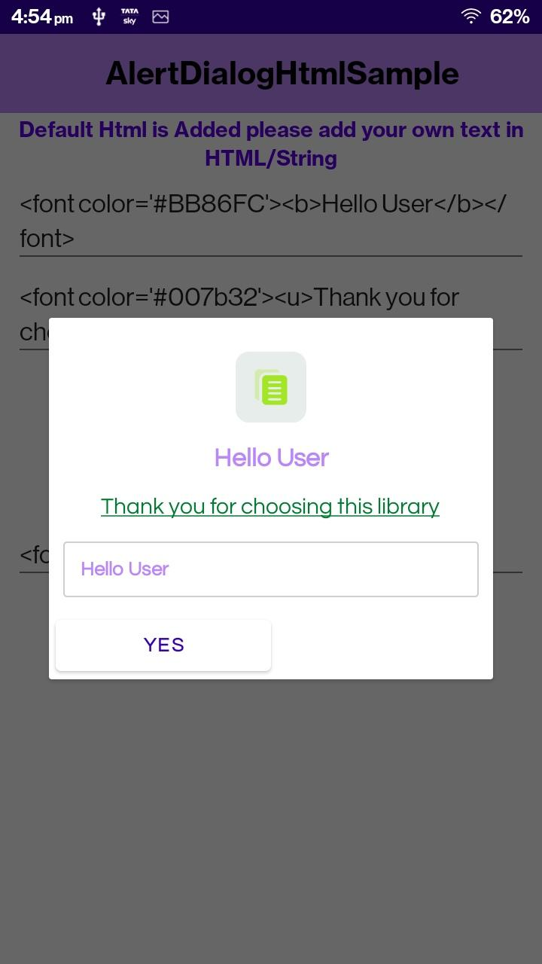

**new AlertDialogHtml.Builder(context)**

**.setTitle(title)**

**.setMessage(msg)**

**.setPositiveBtnText(stringbuttonfirst)**

**.setNegativeBtnText(stringbuttonsecond)**

**.setCancelableOnTouchOutside(true)**

**.setCancelable(true)**

**.setFont(Font.*QUESTRAILREGULAR*)**

**.setImage(R.drawable.*ic_copy*)**

**.setBothButtons(false)**

**.setTitleTextColor(R.color.*purple_700*)**

**.setCustomFont(R.font.*fudgie*)**

**.setHtmlColors(true)**

**.setButtonTextColor(R.color.*purple_200*)**

**.setEditText(true, false, title, InputType.*PASSWORD*)**

**.OnPositiveClicked(new AlertDialogHtmlListner() {**

**@Override**

**public void OnClick(String input) {**

**Toast.*makeText*(context, "Positive"+"Text Value : "+input, Toast.*LENGTH_SHORT*).show();**

**}**

**})**

**.build();**

1. **Dialog with password inputtype :**

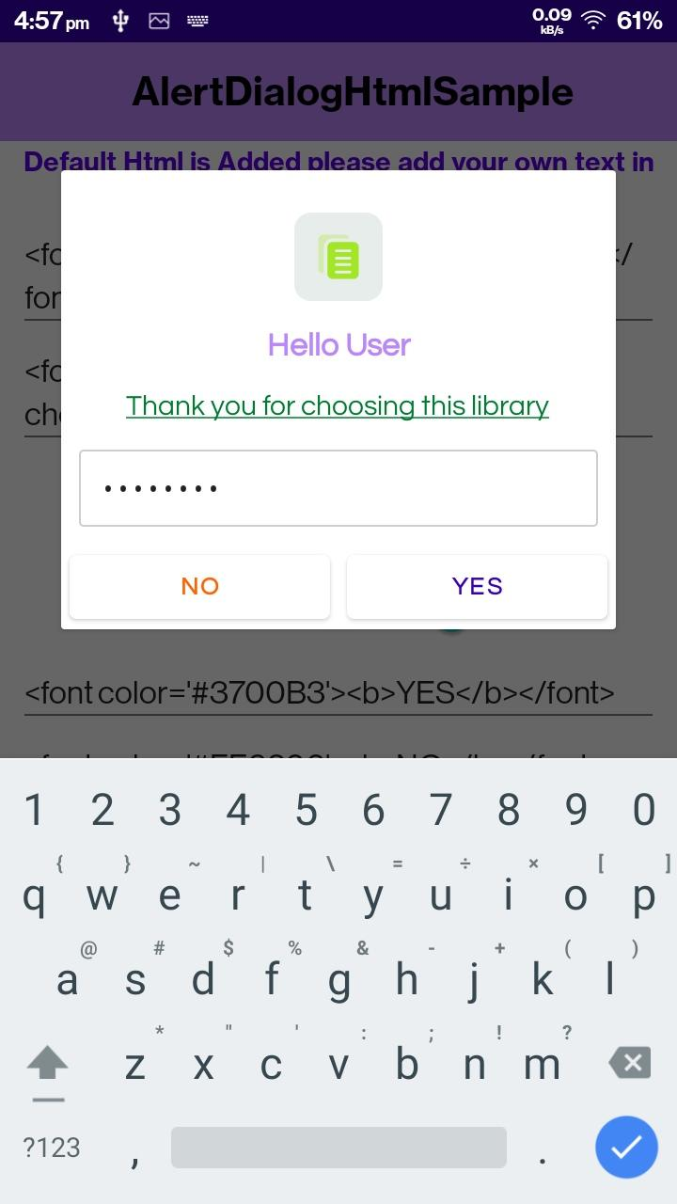

**new AlertDialogHtml.Builder(context)**

**.setTitle(title)**

**.setMessage(msg)**

**.setPositiveBtnText(stringbuttonfirst)**

**.setNegativeBtnText(stringbuttonsecond)**

**.setCancelableOnTouchOutside(true)**

**.setCancelable(true)**

**.setFont(Font.*QUESTRAILREGULAR*)**

**.setImage(R.drawable.*ic_copy*)**

**.setBothButtons(true)**

**.setTitleTextColor(R.color.*purple_700*)**

**.setHtmlColors(true)**

**.setButtonTextColor(R.color.*purple_200*)**

**.setEditText(true, false, title, InputType.*PASSWORD*)**

**.OnPositiveClicked(new AlertDialogHtmlListner() {**

**@Override**

**public void OnClick(String input) {**

**Toast.*makeText*(context, "Positive"+"Text Value : "+input, Toast.*LENGTH_SHORT*).show();**

**}**

**})**

**.OnNegativeClicked(new AlertDialogHtmlListner() {**

**@Override**

**public void OnClick(String input) {**

**Toast.*makeText*(context, "Negative"+"Text Value : "+input, Toast.*LENGTH_SHORT*).show();**

**}**

**})**

**.build();**

1. **Dialog cancelable / cancelable in touch mode : set canclable doesn't cancel even on back press and touch.and cancelable intouch false cancel on back press.**

**new AlertDialogHtml.Builder(context)**

**.setTitle(title)**

**.setMessage(msg)**

**.setPositiveBtnText(stringbuttonfirst)**

**.setNegativeBtnText(stringbuttonsecond)**

**.setCancelableOnTouchOutside(false)**

**.setCancelable(false)**

**.setFont(Font.*QUESTRAILREGULAR*)**

**.setImage(R.drawable.*ic_copy*)**

**.setBothButtons(true)**

**.setTitleTextColor(R.color.*purple_700*)**

**.setAnimation(Animation.*DOWN*)**

**.setHtmlColors(true)**

**.setButtonTextColor(R.color.*purple_200*)**

**.setEditText(true, false, title, InputType.*PASSWORD*)**

**.OnPositiveClicked(new AlertDialogHtmlListner() {**

**@Override**

**public void OnClick(String input) {**

**Toast.*makeText*(context, "Positive"+"Text Value : "+input, Toast.*LENGTH_SHORT*).show();**

**}**

**})**

**.OnNegativeClicked(new AlertDialogHtmlListner() {**

**@Override**

**public void OnClick(String input) {**

**Toast.*makeText*(context, "Negative"+"Text Value : "+input, Toast.*LENGTH_SHORT*).show();**

**}**

**})**

**.build();**

1. **Dialog with Image as drawable/Image url /File :**



**new AlertDialogHtml.Builder(context)**

**.setTitle(title)**

**.setMessage(msg)**

**.setPositiveBtnText(stringbuttonfirst)**

**.setNegativeBtnText(stringbuttonsecond)**

**.setCancelableOnTouchOutside(true)**

**.setCancelable(true)**

**.setFont(Font.*QUESTRAILREGULAR*)**

**.setImage(R.drawable.*ic_copy*)**

**.setBothButtons(isBothBUtton)**

**.setTitleTextColor(R.color.*purple_700*)**

**.setHtmlColors(isHtmlColor)**

**.setButtonTextColor(R.color.*purple_200*)**

**.setEditText(true, false, title, InputType.*PASSWORD*)**

**.OnPositiveClicked(new AlertDialogHtmlListner() {**

**@Override**

**public void OnClick(String input) {**

**Toast.*makeText*(context, "Positive"+"Text Value : "+input, Toast.*LENGTH_SHORT*).show();**

**}**

**})**

**.OnNegativeClicked(new AlertDialogHtmlListner() {**

**@Override**

**public void OnClick(String input) {**

**Toast.*makeText*(context, "Negative"+"Text Value : "+input, Toast.*LENGTH_SHORT*).show();**

**}**

**})**

**.build();**

1. **Add Animations UP and DOWN as of now as Parameter :**



**new AlertDialogHtml.Builder(context)**

**.setTitle(title)**

**.setMessage(msg)**

**.setPositiveBtnText(stringbuttonfirst)**

**.setNegativeBtnText(stringbuttonsecond)**

**.setCancelableOnTouchOutside(true)**

**.setCancelable(true)**

**.setFont(Font.*QUESTRAILREGULAR*)**

**.setImage(R.drawable.*ic_copy*)**

**.setBothButtons(isBothBUtton)**

**.setTitleTextColor(R.color.*purple_700*)**

**.setAnimation(Animation.*DOWN*)//UP**

**.setHtmlColors(isHtmlColor)**

**.setButtonTextColor(R.color.*purple_200*)**

**.setEditText(true, false, title, InputType.*PASSWORD*)**

**.OnPositiveClicked(new AlertDialogHtmlListner() {**

**@Override**

**public void OnClick(String input) {**

**Toast.*makeText*(context, "Positive"+"Text Value : "+input, Toast.*LENGTH_SHORT*).show();**

**}**

**})**

**.OnNegativeClicked(new AlertDialogHtmlListner() {**

**@Override**

**public void OnClick(String input) {**

**Toast.*makeText*(context, "Negative"+"Text Value : "+input, Toast.*LENGTH_SHORT*).show();**

**}**

**})**

**.build();**

1. **Add a different font from the font file (ttf).**

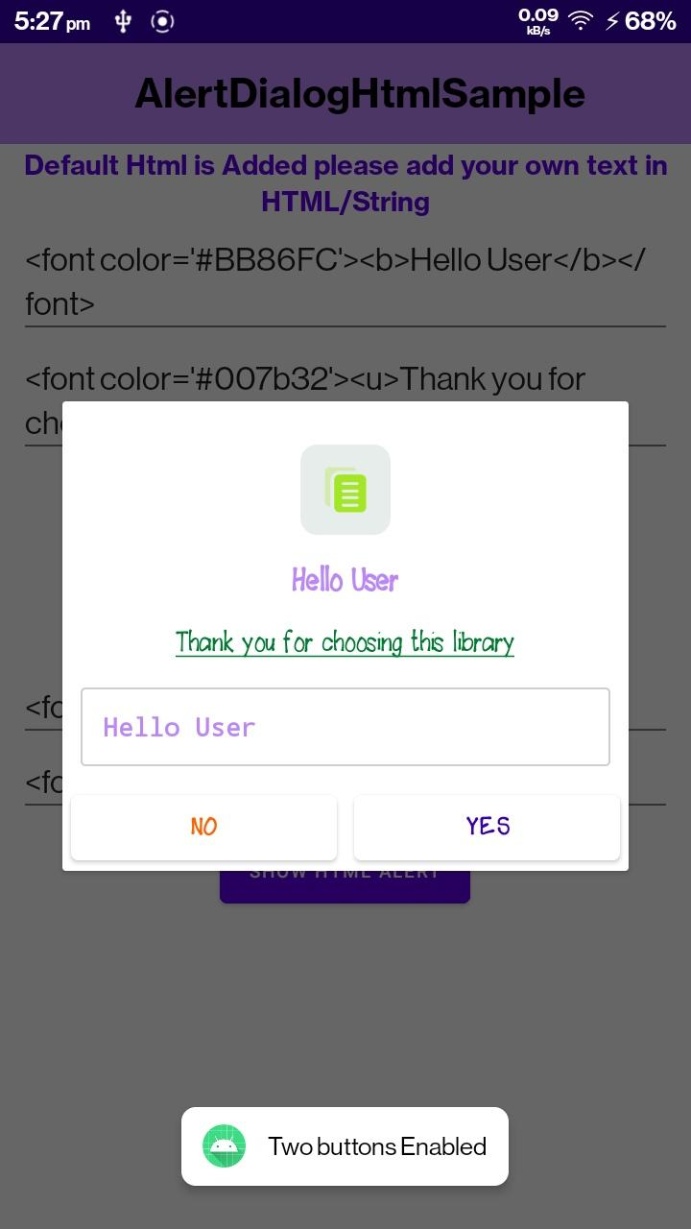

**new AlertDialogHtml.Builder(context)**

**.setTitle(title)**

**.setMessage(msg)**

**.setPositiveBtnText(stringbuttonfirst)**

**.setNegativeBtnText(stringbuttonsecond)**

**.setCancelableOnTouchOutside(true)**

**.setCancelable(true)**

**.setFont(Font.*QUESTRAILREGULAR*)**

**.setImage(R.drawable.*ic_copy*)**

**.setBothButtons(isBothBUtton)**

**.setTitleTextColor(R.color.*purple_700*)**

**.setCustomFont(R.font.*fudgie*)**

**.setAnimation(Animation.*DOWN*)**

**.setHtmlColors(isHtmlColor)**

**.setButtonTextColor(R.color.*purple_200*)**

**.setEditText(true, false, title, InputType.*PASSWORD*)**

**.OnPositiveClicked(new AlertDialogHtmlListner() {**

**@Override**

**public void OnClick(String input) {**

**Toast.*makeText*(context, "Positive"+"Text Value : "+input, Toast.*LENGTH_SHORT*).show();**

**}**

**})**

**.OnNegativeClicked(new AlertDialogHtmlListner() {**

**@Override**

**public void OnClick(String input) {**

**Toast.*makeText*(context, "Negative"+"Text Value : "+input, Toast.*LENGTH_SHORT*).show();**

**}**

**})**

**.build();**